sqm

1 0.829904

0 0.170096

What does the data looks like with the 17% and without?

**Square meters**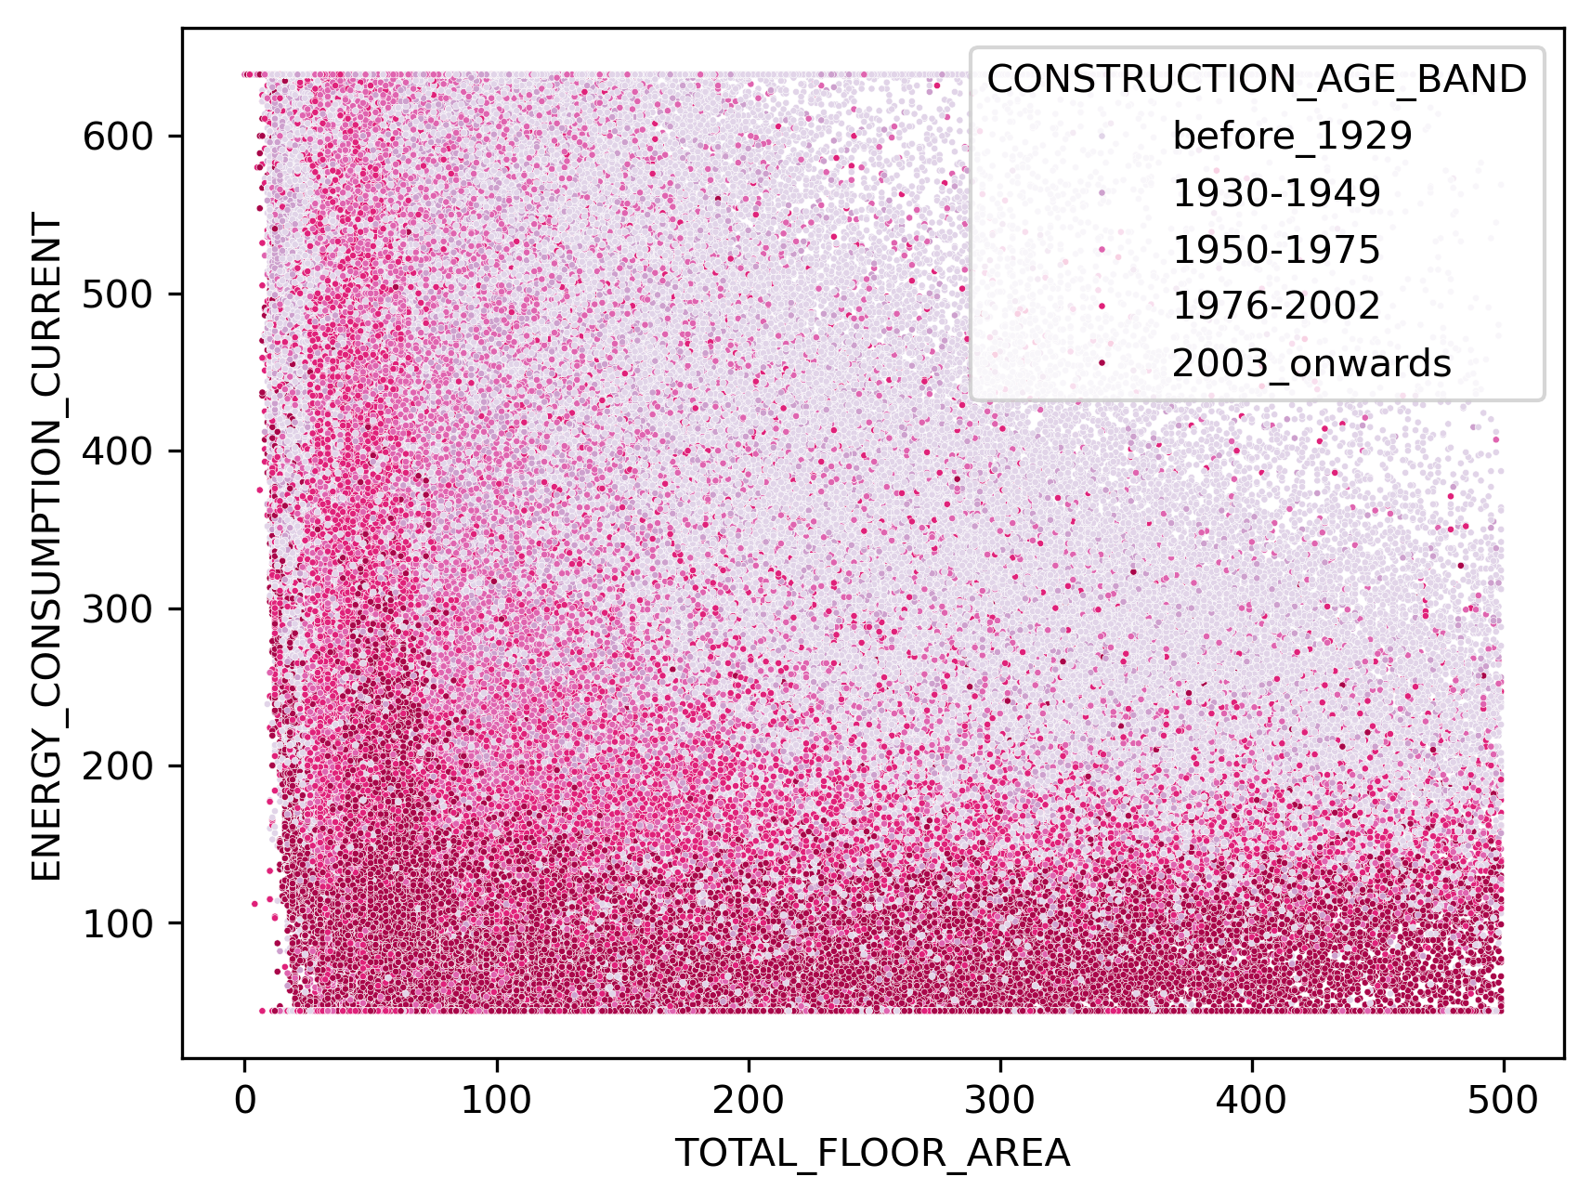

**Square Feet**

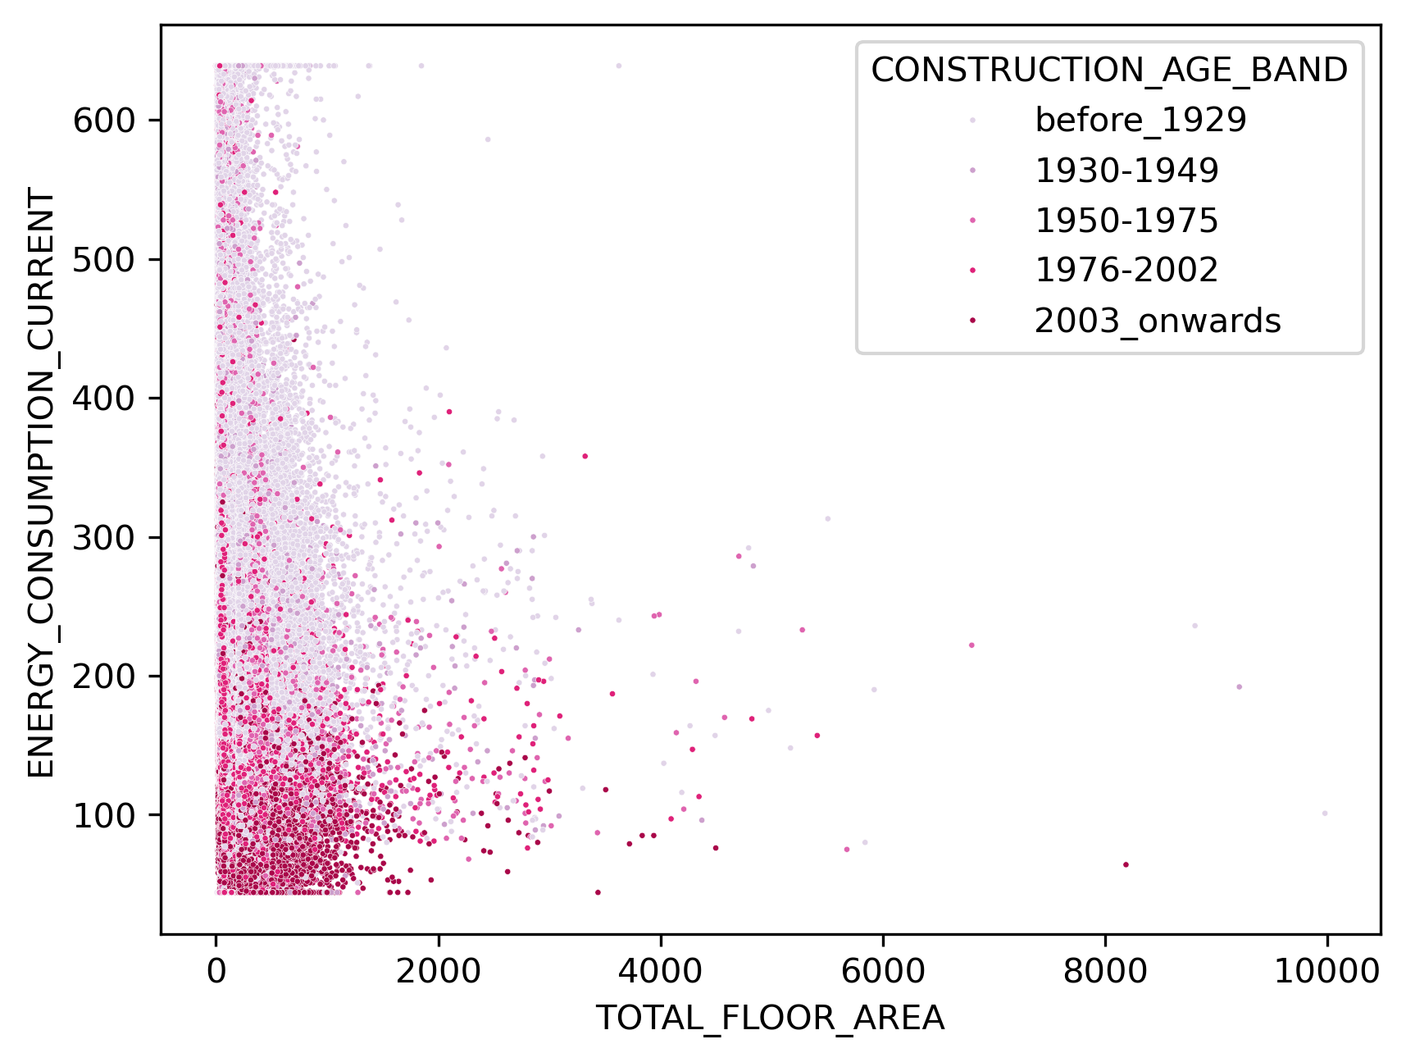

Specifically look at the possible sq feet measurement for flats

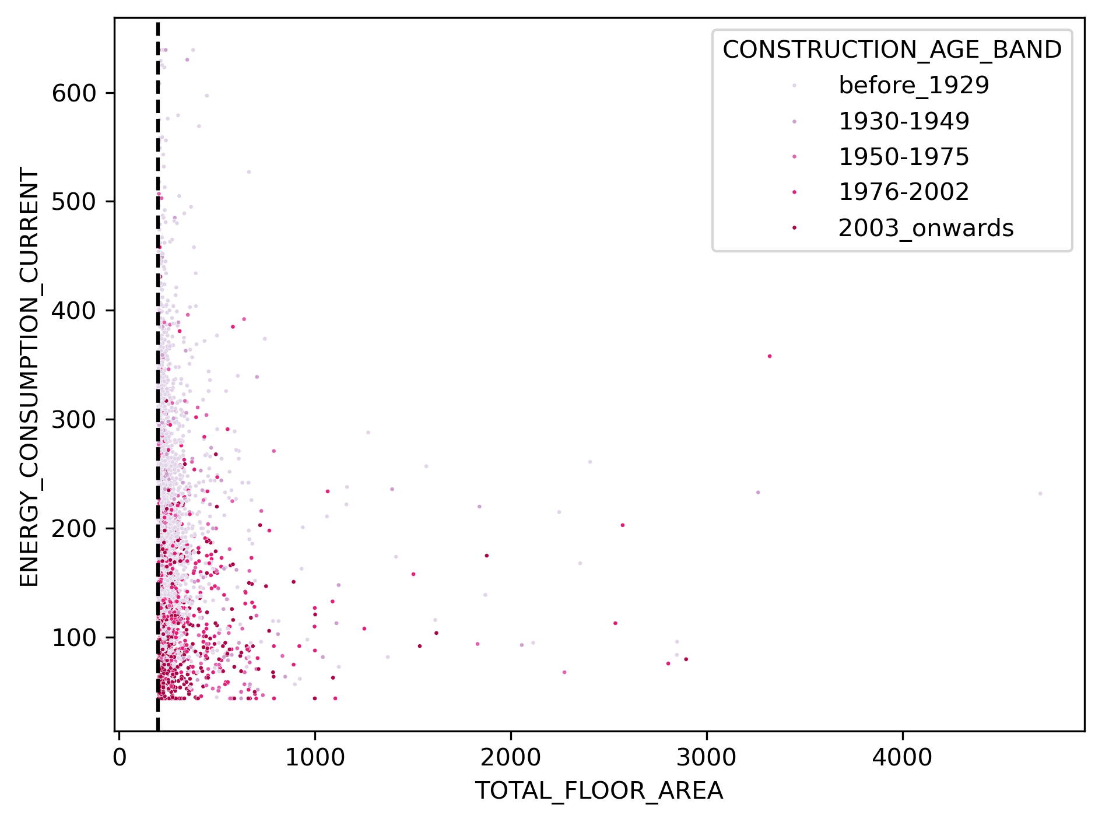

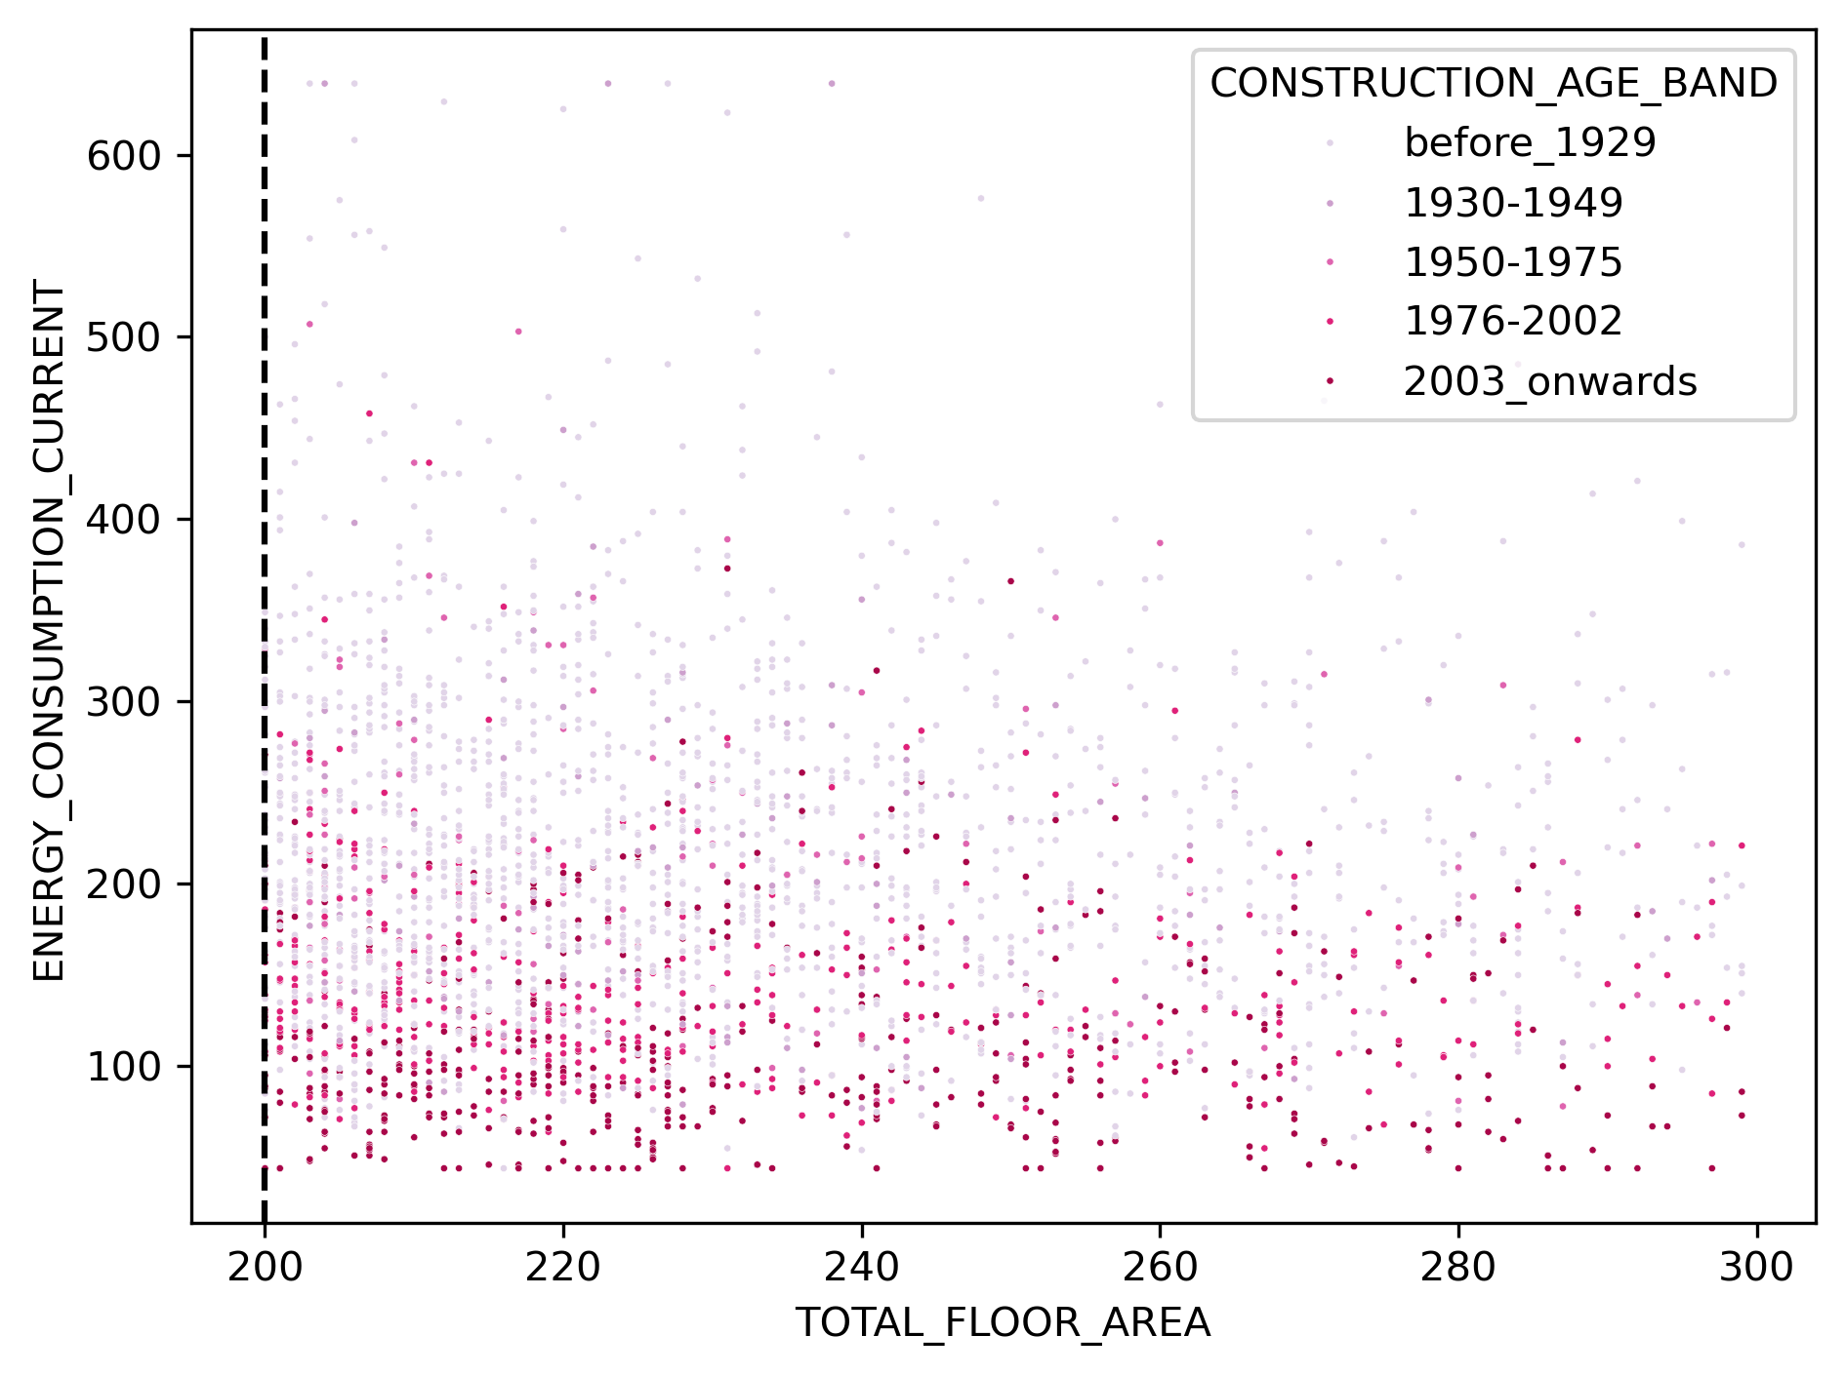

3 random properties

1. Value 250, flat 1930-1949 with 71sqm/764sq feet (

|  |  |  |
| --- | --- | --- |
| 50.786729 | -1.084004 |  |

1. Value 221 flat rented 2003 onwards, with probably 146 sqm/ 1571sqfeet

|  |  |  |
| --- | --- | --- |
| 53.575912 | -2.442664 |  |

If I only work with the 87% identified properties in sq2, is it going to change the mean and median for the data?

MEAN

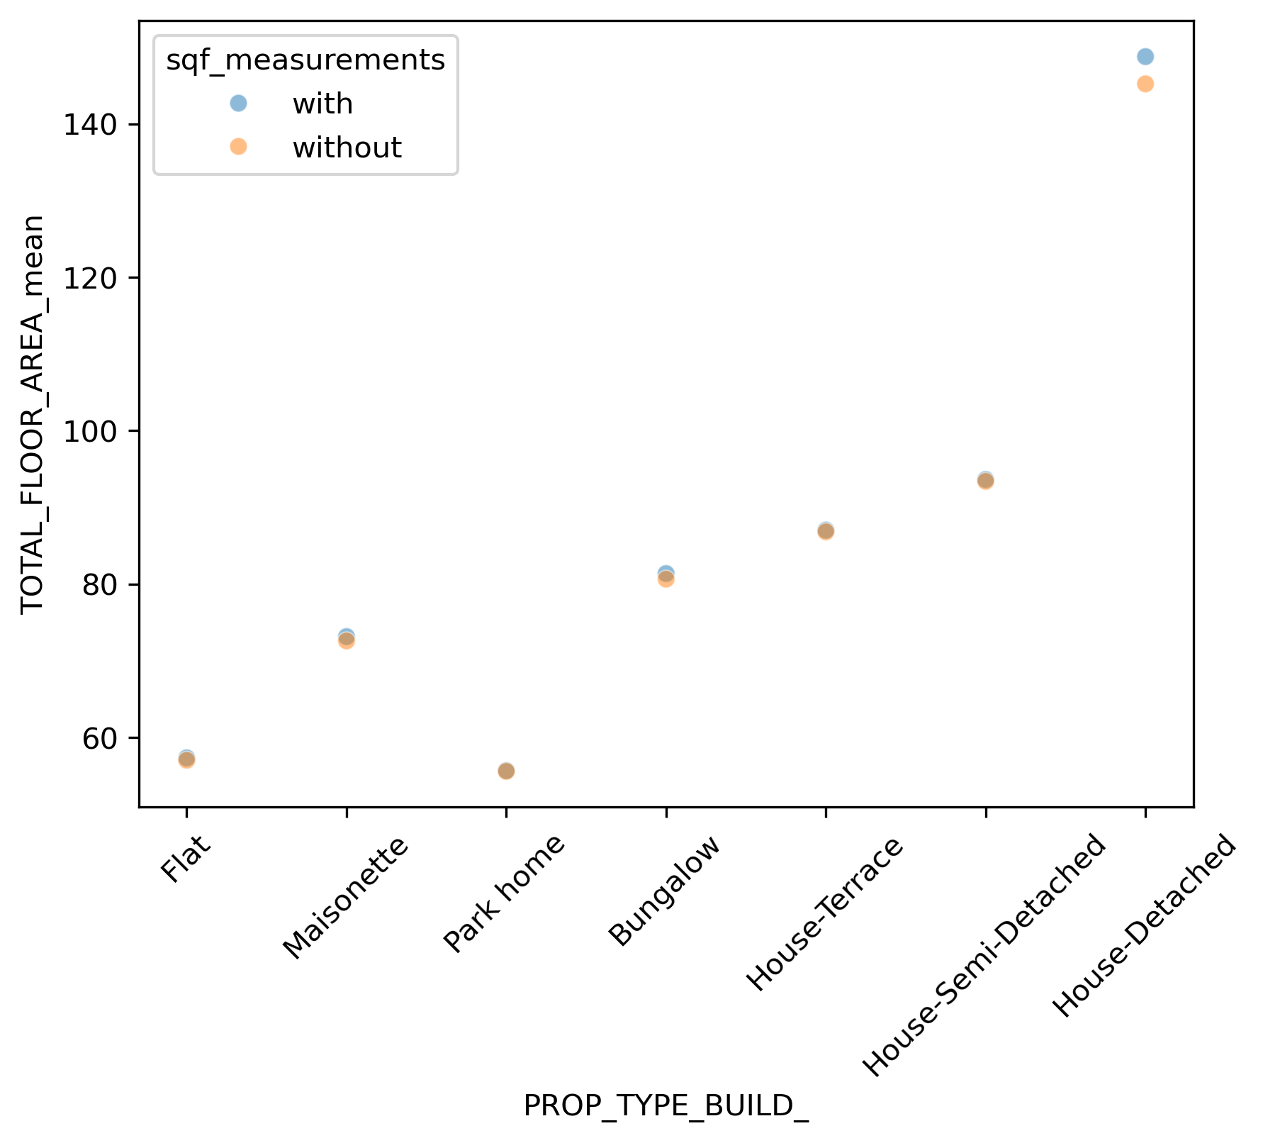

MEDIAN

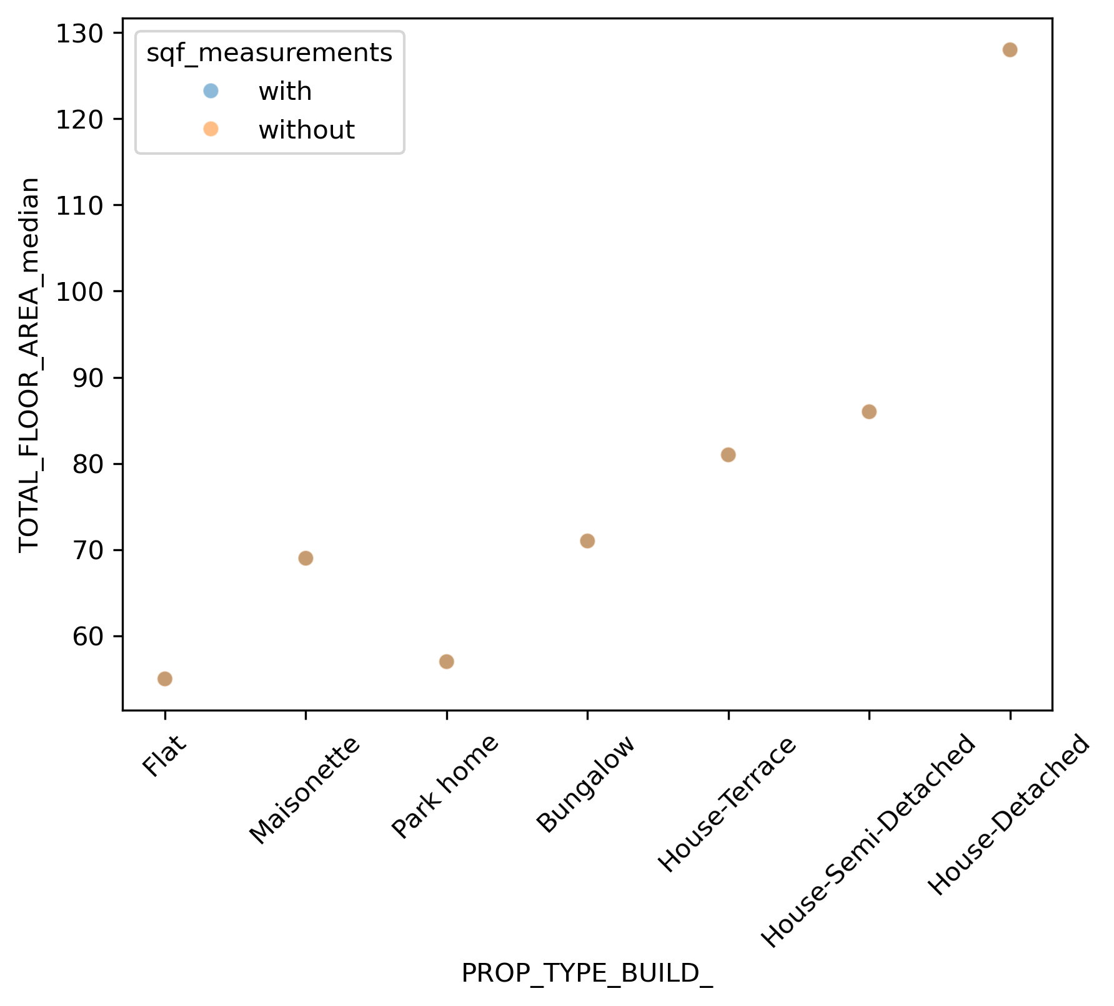

Ok, when I only take the sqm2 measurements, what does the floor are against consumption looks like?

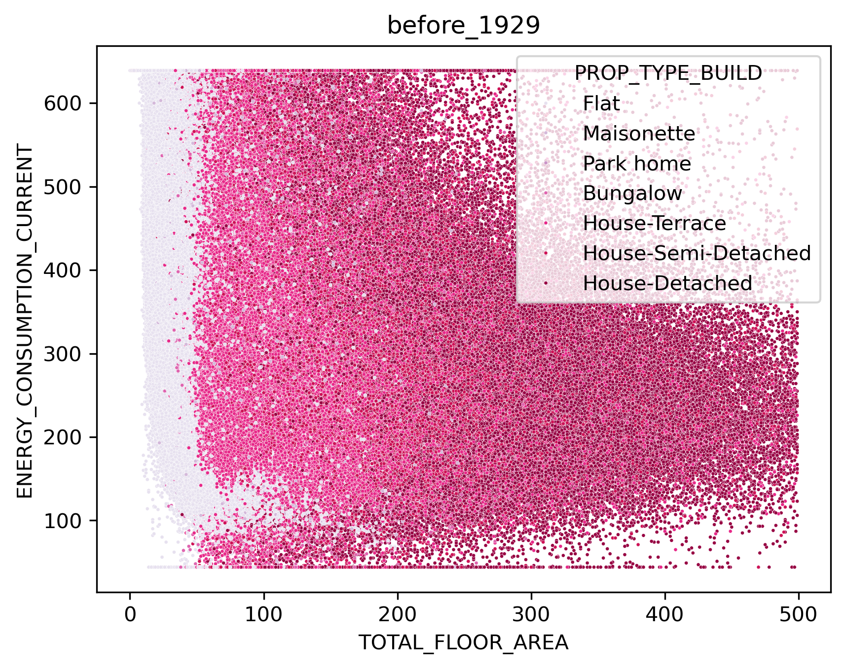 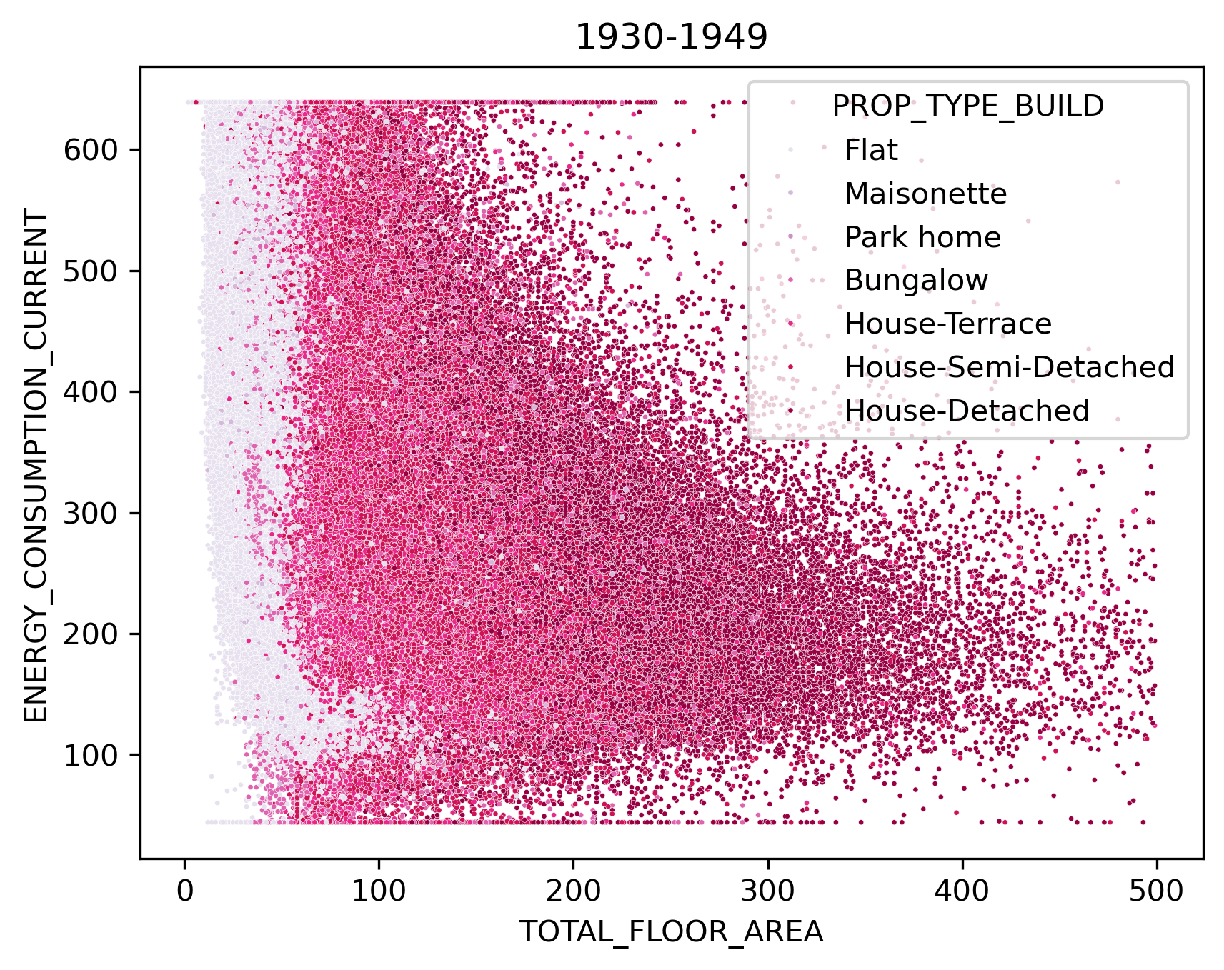 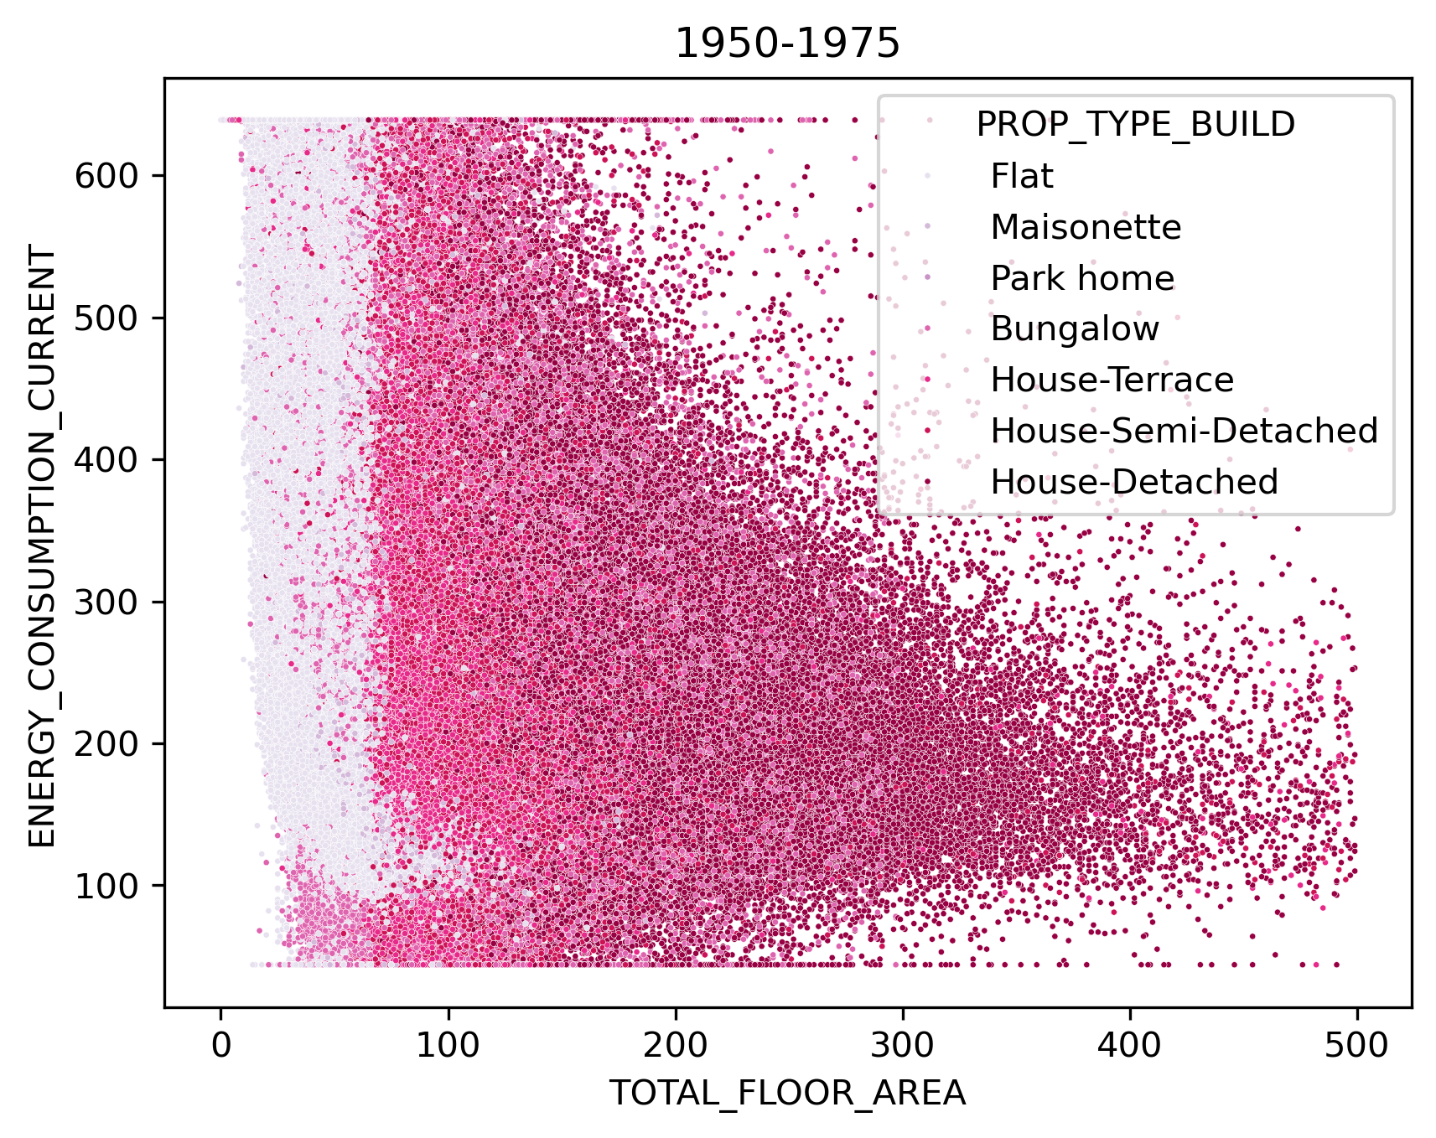 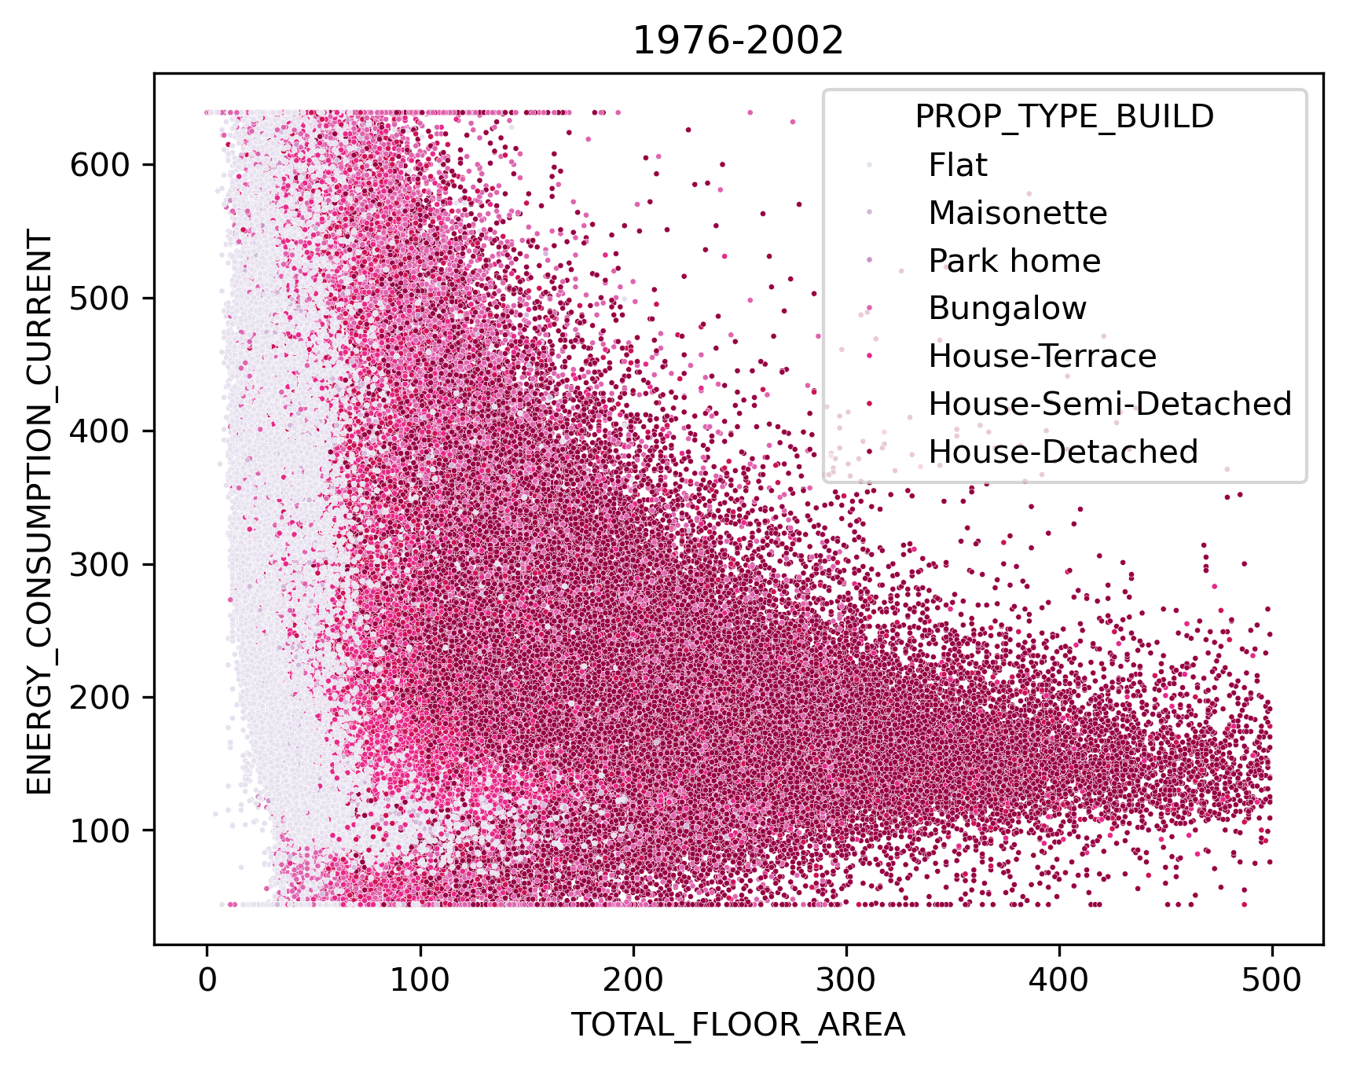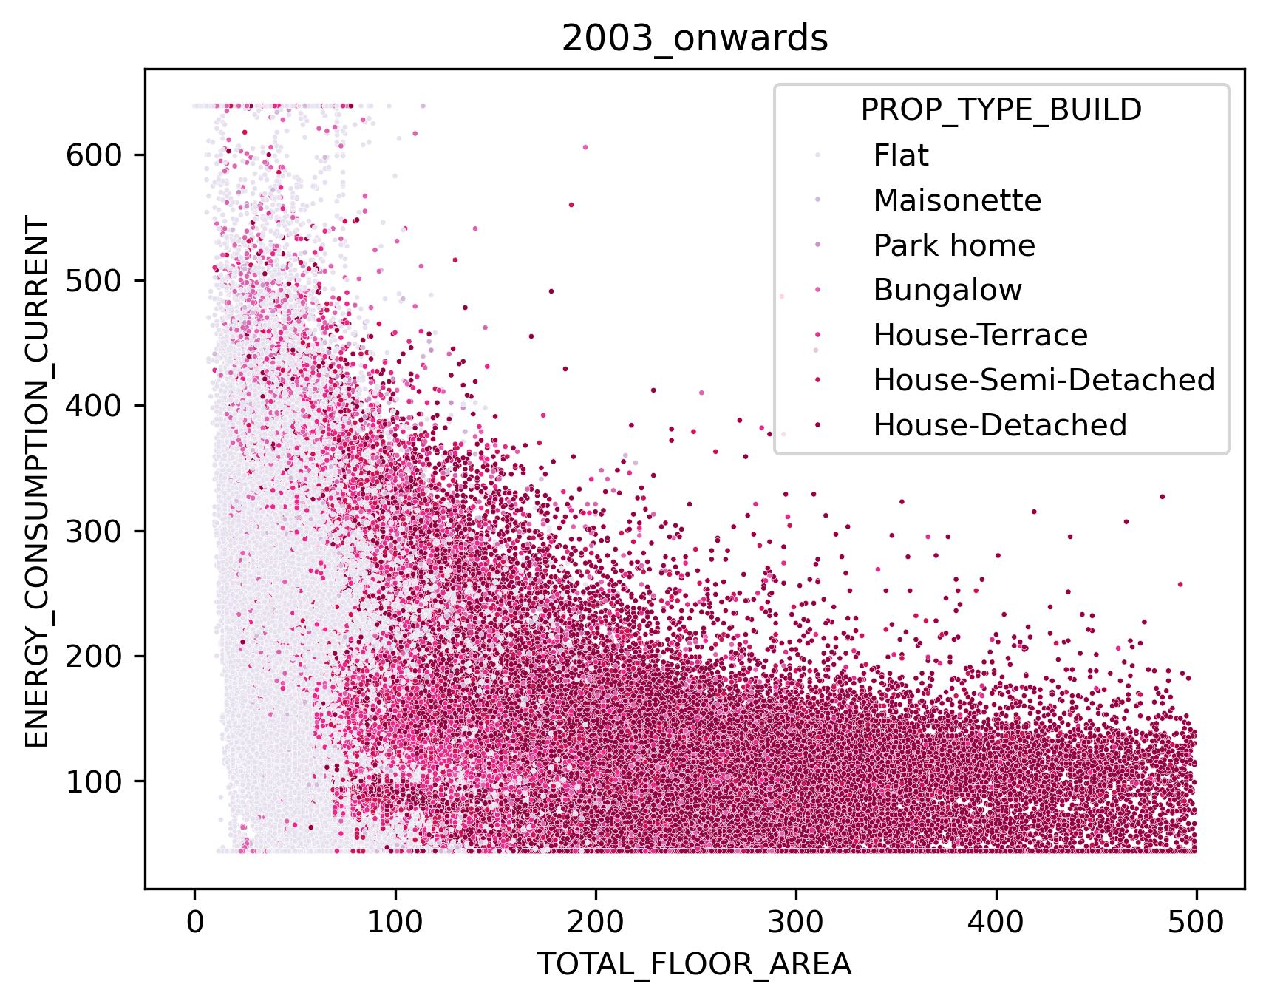  Energy consumption in (kWh/m2)

Flip

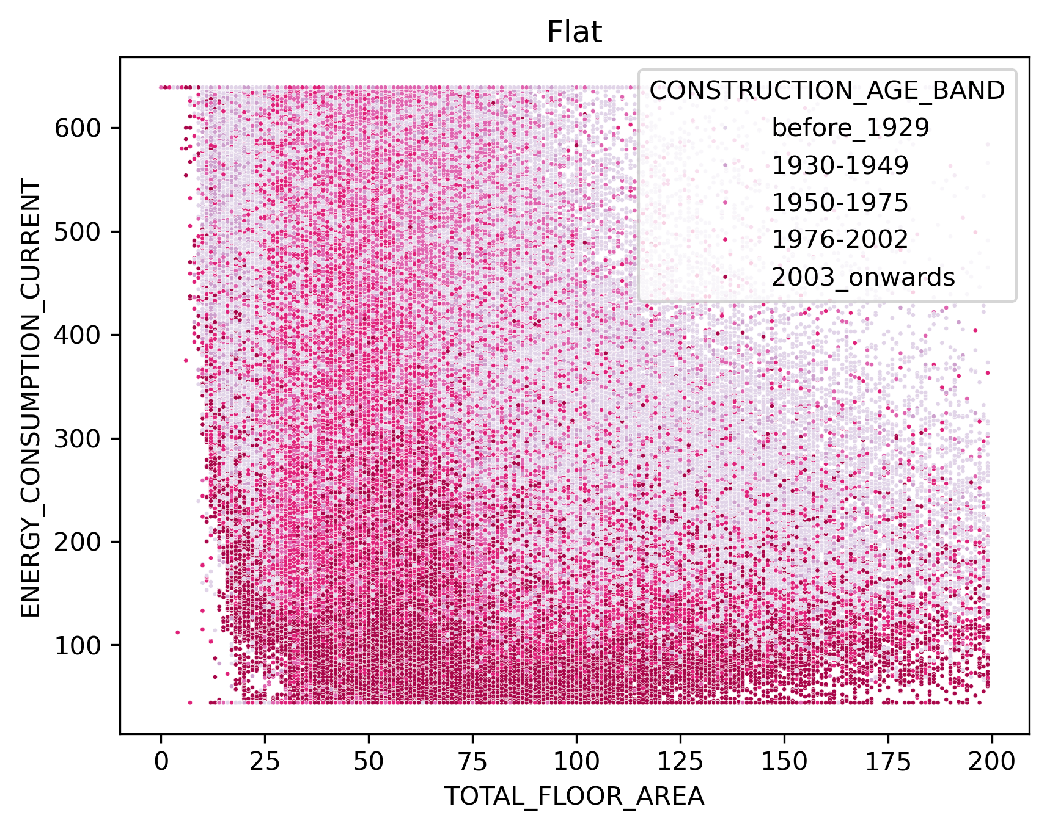 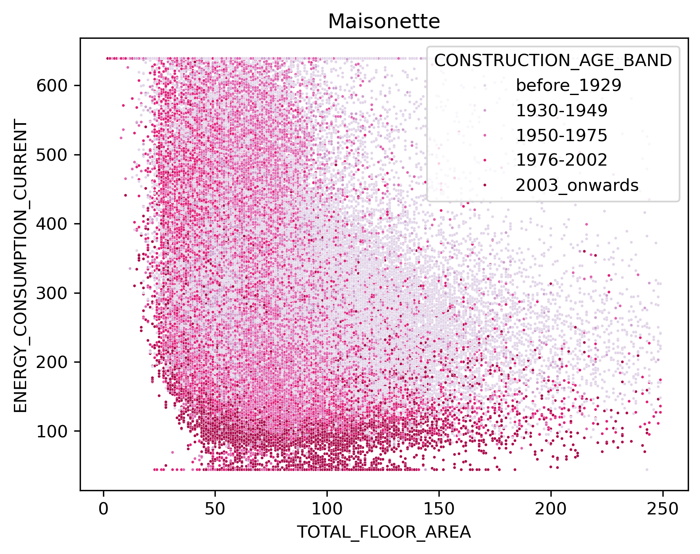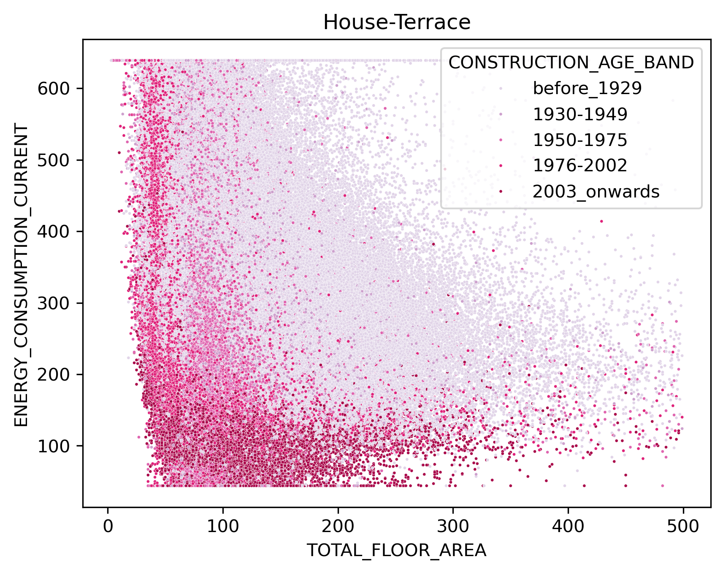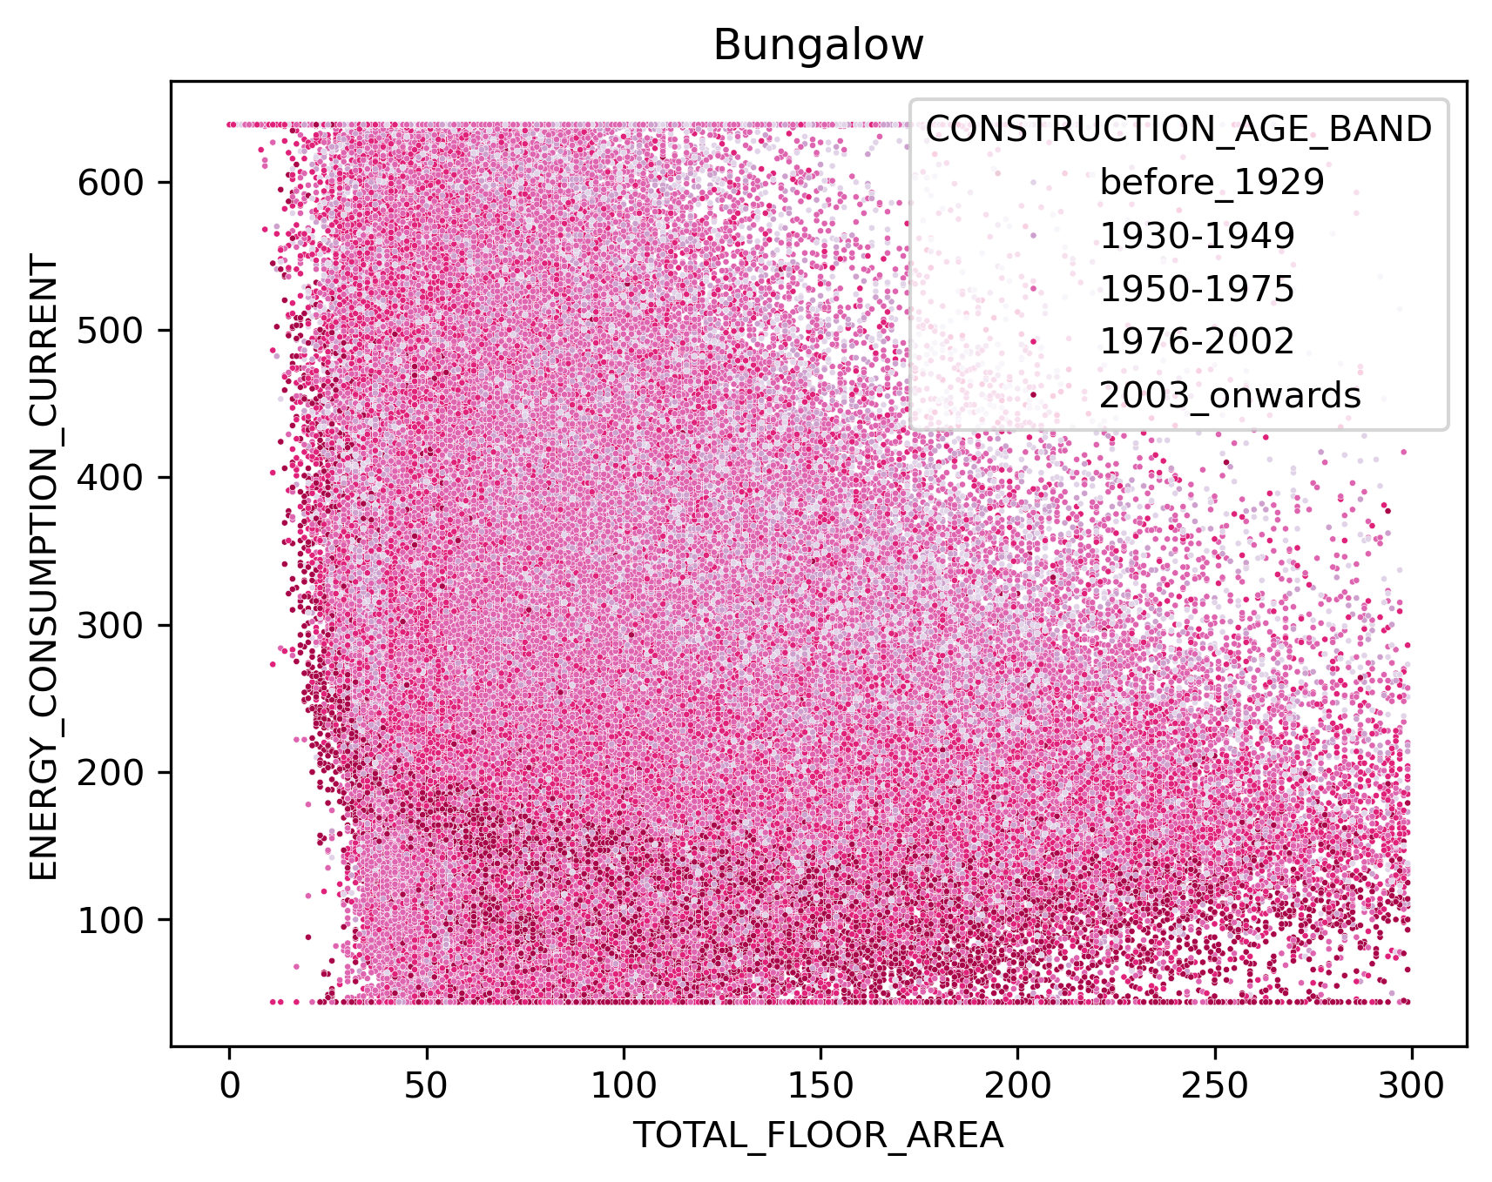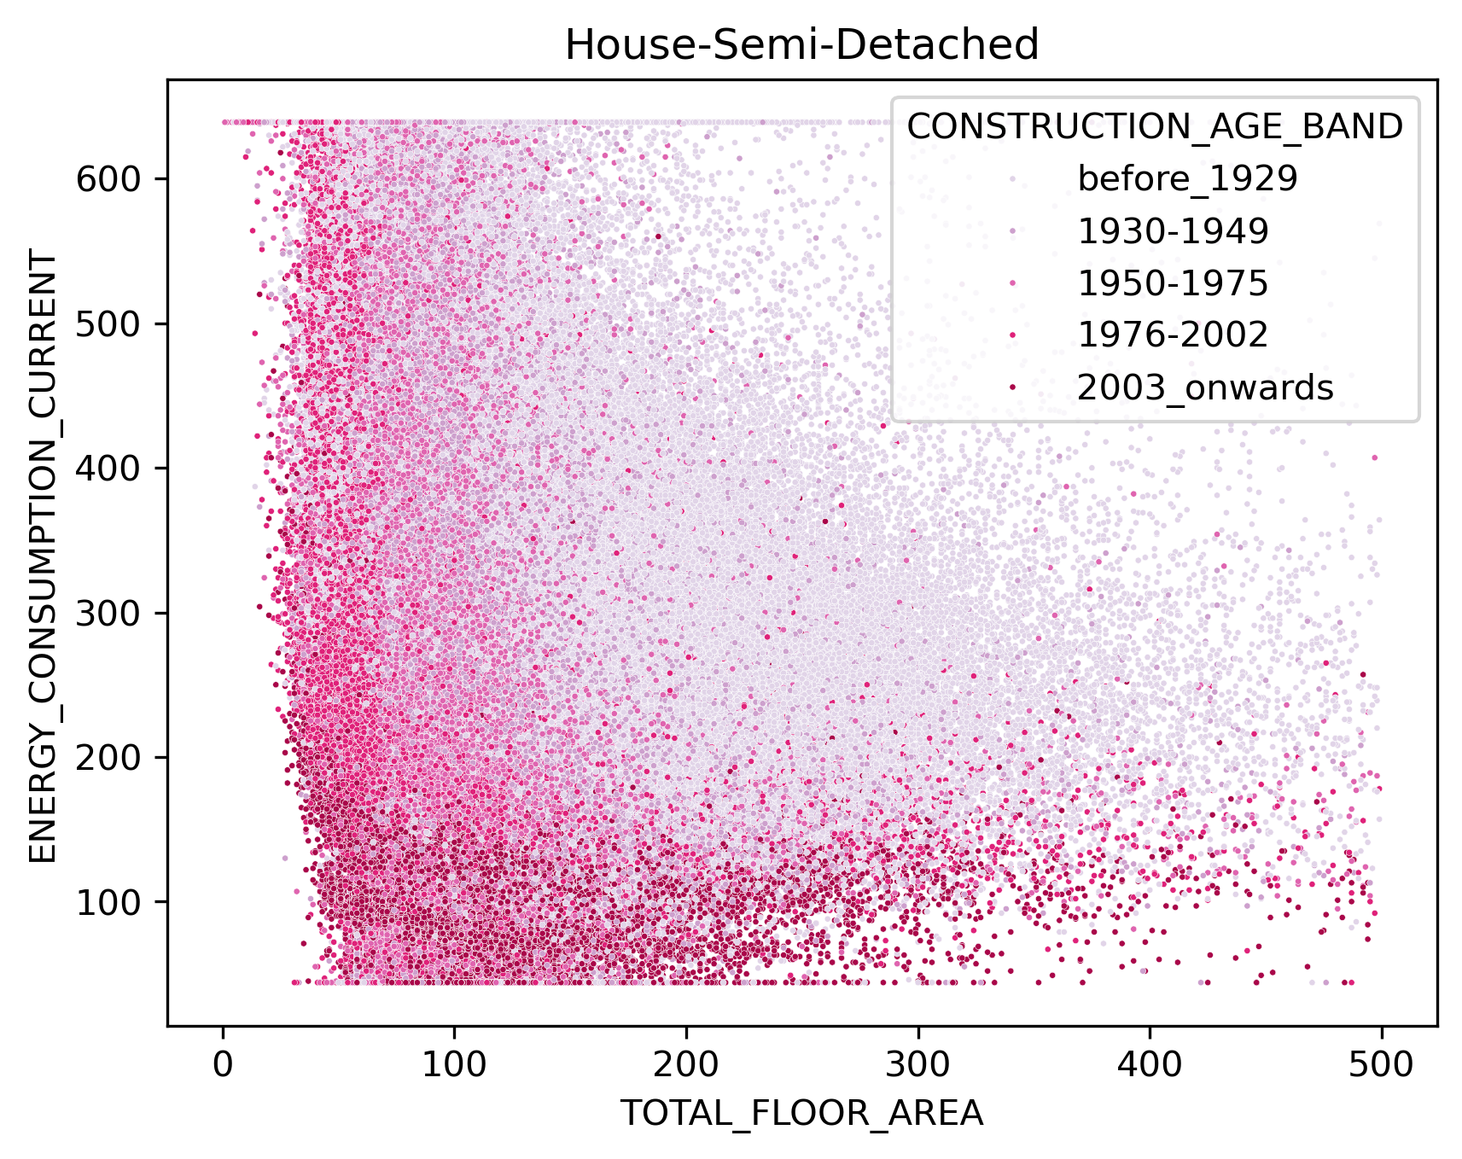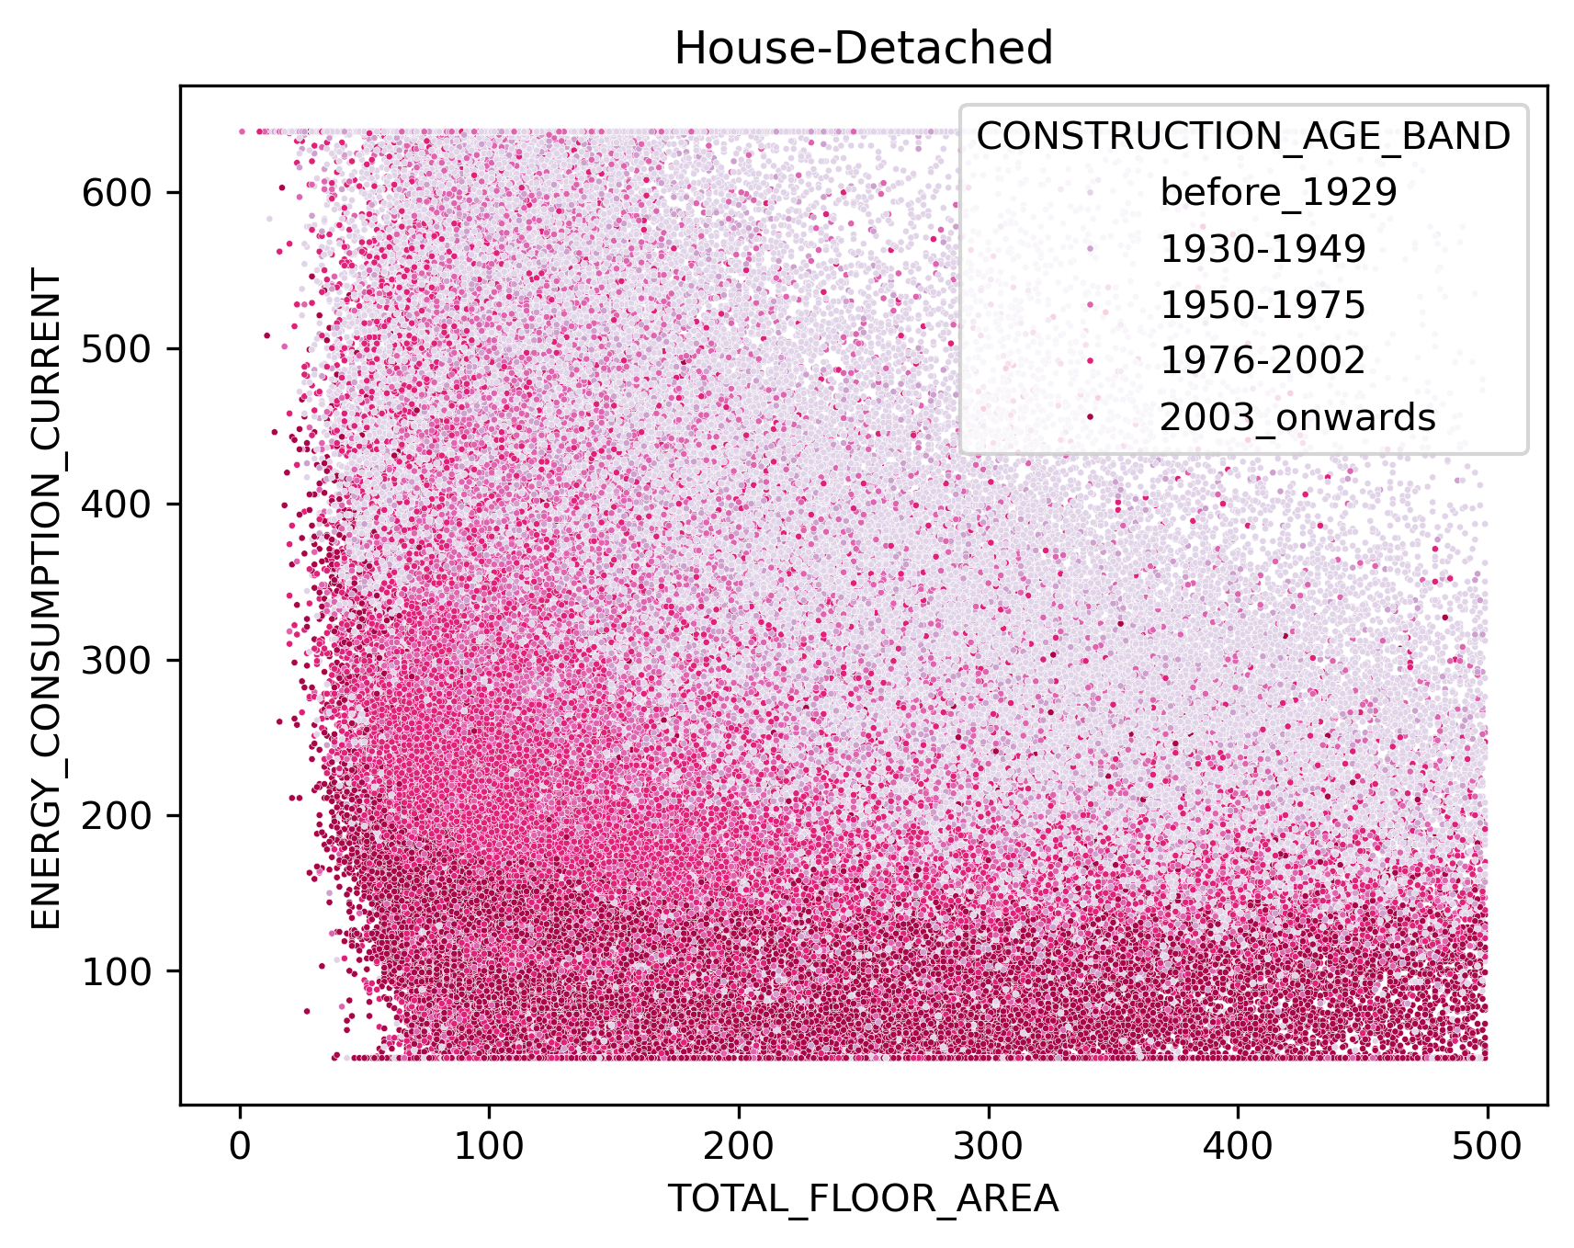 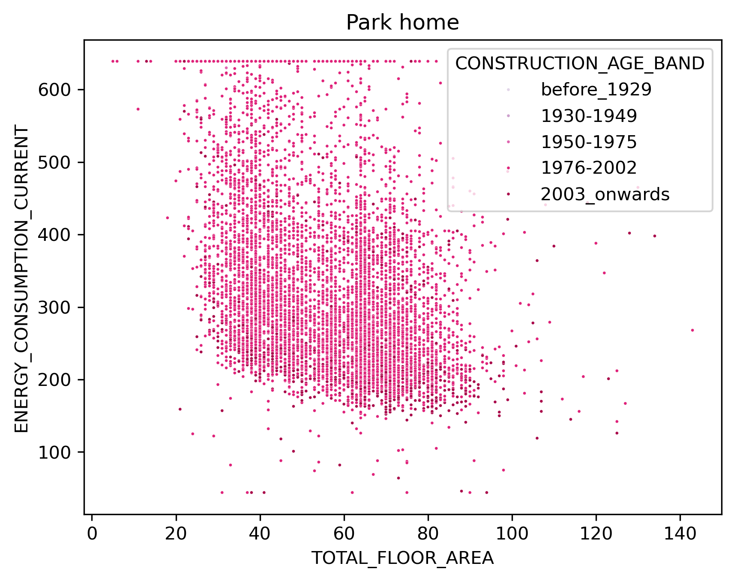

Consumption data with EPC

Coverage

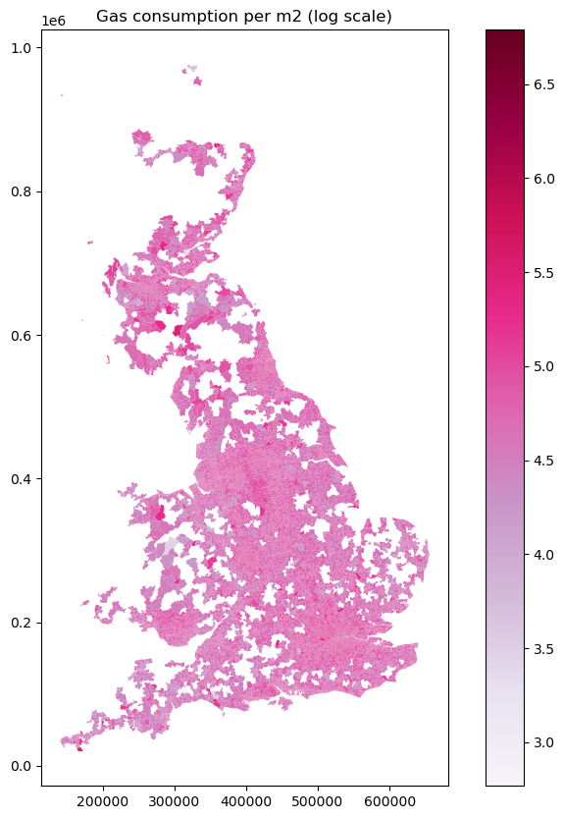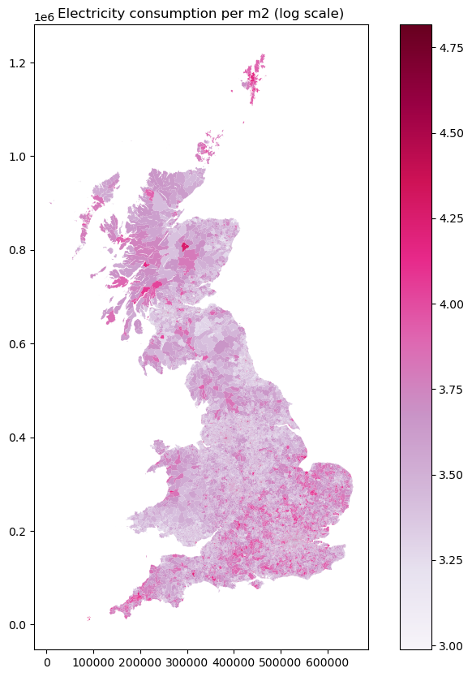

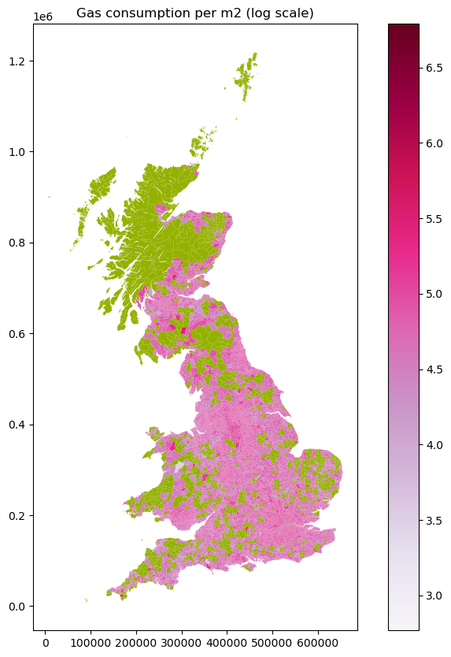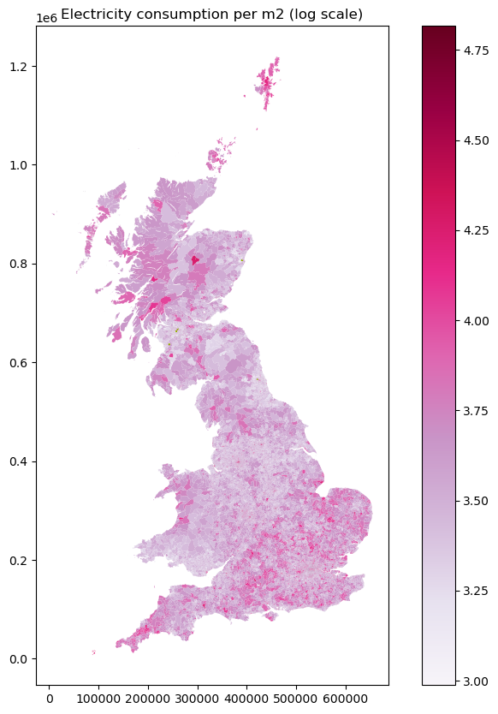

Missing data for gas

Rural 1432 0.94709 == 4% of all rural areas which is 16% of all rural households

Urban 80 0.05291 == only 0.16% of all the urban households

Missing data for electricity is only for areas in Scottland that are currently inactive

